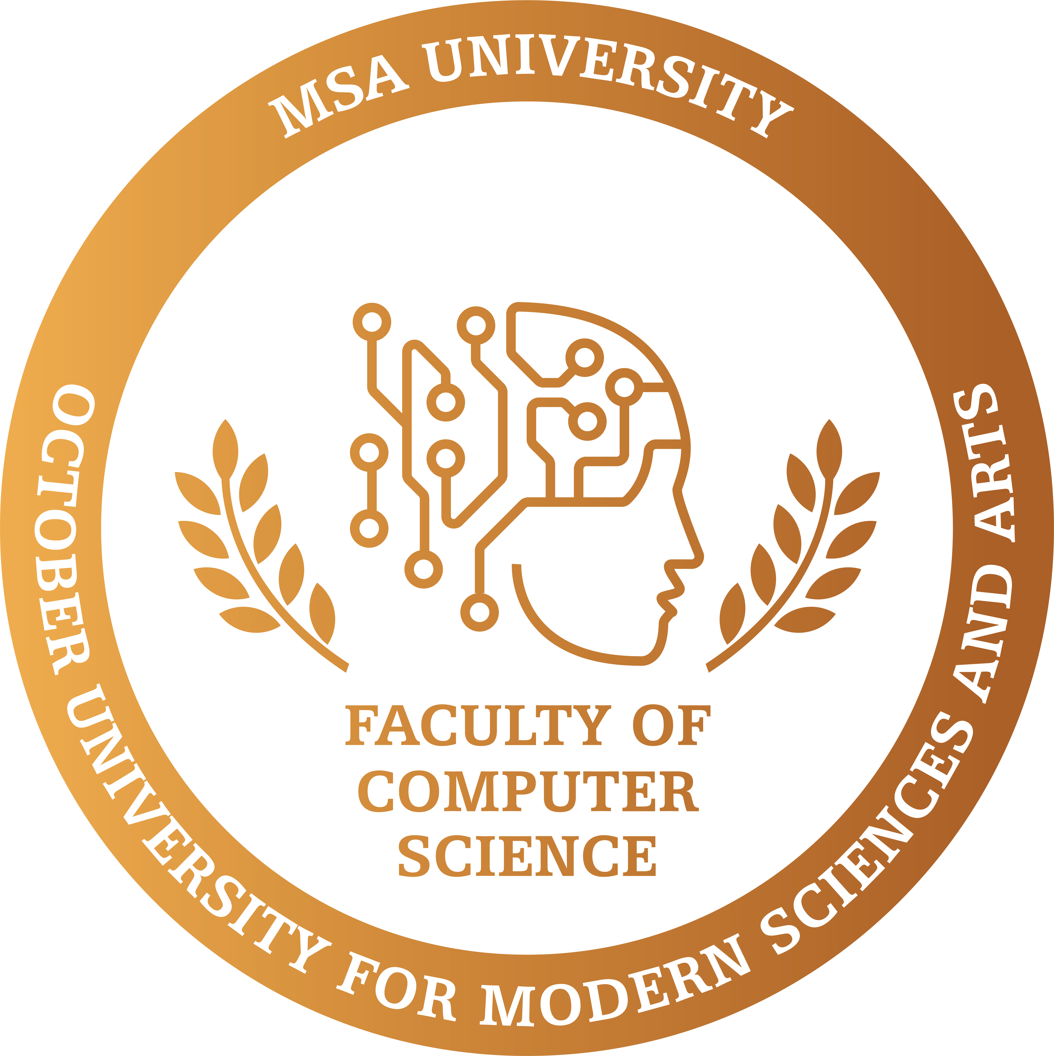

Evaluation of tooth preparation accuracy and comparison between conventional methods and scanner techniques by using machine learning

by

Habiba Adel

A dissertation submitted in partial fulfillment of the requirements for the degree of

Bachelor of computer science (SE programme) in the

Faculty of Computer Science of the

October University for Modern Sciences and Arts (MSA), EGYPT

Graduation Projects advisor:

Dr. Hesham Mansour

(October 2023)

Abstract

Accurate evaluation of tooth preparation is critical in dentistry, as it directly affects the quality of tooth restoration. Conventional methods for assessing tooth preparation often exhibit subjectivity and limitations in accuracy. Conversely, the advent of digital scanning technologies offers a promising alternative. This study presents an innovative approach that takes advantage of machine learning algorithms to accurately compare traditional methods with modern scanner techniques in evaluating the accuracy of tooth preparation. To identify the differences between traditional and modern methods, a variety of machine learning algorithms have been used. Notably, support vector machines (SVMs) are used to classify and differentiate the two approaches based on critical criteria such as margin quality and occlusal reduction. Furthermore, convolutional neural networks (CNNs) are used to extract and analyze complex features from dental images, allowing a deeper understanding of differences in preparation quality.

# Contents

Abstract ii

List of Tables 5

List of Figures 6

1. Introduction 7

1.1 Introduction . . . . . . . . . . . . . . . . . . . . . . . . . . . . . . . . . . . . 7

1.2 Problem Statement . . . . . . . . . . . . . . . . . . . . . . . . . . . . . . . . 8

1.3 Objective . . . . . . . . . . . . . . . . . . . . . . . . . . . . . . . . . . . . . 8

1.4 Motivation . . . . . . . . . . . . . . . . . . . . . . . . . . . . . . . . . . . . 9

1. Background 10

2.1 Gap analysis . . . . . . . . . . . . . . . . . . . . . . . . . . . . . . . . . . . 10

2.2 literature review . . . . . . . . . . . . . . . . . . . . . . . . . . . . . . . . . 11

1. Specification - (SRS) 11
   1. Introduction 11
      1. Scope of this document 11
      2. Overview 12
      3. Business Context 12
   2. General Description 13
      1. Product Functions 13
      2. Similar System Information 14
      3. User Characteristics 15
      4. User Problem Statement 16
      5. User Objectives 16
      6. General Constraints 16
   3. Functional Requirements 17
   4. Interface Requirements 20
      1. User Interfaces 20
      2. Hardware Interfaces 22
      3. Communications Interfaces 22
   5. Performance Requirements 23
   6. Design Constraints 23
      1. Standards Compliance 23
      2. Hardware Limitations 23
   7. Other non-functional attributes 23
      1. Security 23
      2. Reliability 24
      3. Maintainability 24
      4. Portability 24
      5. Extensibility 24
      6. Re-usability 24
   8. Preliminary Object-Oriented Domain Analysis 24
      1. Inheritance Relationships 25
      2. Class descriptions 25
   9. Operational Scenarios 29
   10. Preliminary Schedule Adjusted 31
       1. Collected material 31
2. Design 32
   1. Introduction 32
      1. Purpose 32
      2. Scope 32
      3. Overview 32
   2. Tools 32
   3. Definitions 34
   4. System Overview 36
   5. System Architecture 36
      1. Architectural Design 36
      2. Decomposition Description 38
      3. Design Rationale 39
   6. Data Design 45
      1. Data Description 45
      2. Data Dictionary 46
   7. Component Design 47
   8. Humnan Interface Design 47
      1. Overview of User Interface 47
      2. Screen Images 48

Requirements Matrix 49

**Chapter 1**

# Introduction

## Introduction

Traditional plaster models of dental structures are indispensable diagnostic tools for the assessment of occlusion, three-dimensional dentition, and the severity of malocclusion, all of which hold pivotal roles in clinical orthodontic evaluations. Plaster models have long been hailed as the "gold-standard" for arch space analysis due to their exceptional accuracy and cost-effectiveness. However, the process of obtaining impressions, crafting the models, and conducting subsequent analyses is notably laborious and time intensive. Furthermore, concerns regarding breakage, storage costs, and the bulkiness of plaster models have spurred a search for modern techniques to address these drawbacks. In the contemporary landscape of orthodontics, the digitalization of dental study models represents an advancing development. The replacement of traditional plaster models with these innovative virtual counterparts yields a multitude of advantages. These benefits include enhanced operational efficiency, immediate access to digital patient records, swift data exchange for consultations and referrals, cost savings by eliminating the need for plaster model storage and mitigating the risk of damage or loss, time savings through streamlined digital measurements, and improved production capabilities, including the potential for digital setups. In modern dentistry, spanning from restorative procedures to orthodontic practices, there is a prevalent trend toward simplified, entirely digital workflows. The concept of digital dentistry aims to empower dentists to operate with heightened efficiency, enhanced precision, and the capacity to provide comprehensive, in-house treatment sessions using computerized techniques. Within this workflow, one of the primary tools for simulating and executing dental treatments is imaging, with Cone Beam Computed Tomography (CBCT) imaging playing a pivotal role and gaining substantial prominence in the market. However, despite the streamlining of numerous processes within digital dentistry, several inherent limitations persist. These limitations, no matter how simplified the workflow becomes, have the potential to compromise precision and introduce clinical complexities. Hence, the primary objective of this study is to evaluate the accuracy and reliability of 3D and 2D images obtained through CBCT when used for the analysis of dental arch space, including a comprehensive assessment of the measurements between these digital images and their traditional plaster model counterparts.

## 1.2 Problem Statement

Previous studies relied on traditional measurements taken by students in addition to digital scanning techniques to assess the accuracy of tooth preparation. In contrast, by using just digital scanning techniques and the usage of machine learning algorithms, this study seeks to improve the efficacy and accuracy of these examinations. The primary goal is: Elevate the accuracy of dental readiness assessments by leveraging advanced digital scanning technologies to capture comprehensive, highly detailed data regarding tooth preparations. Leverage the power of machine learning algorithms to analyze this exclusive digital data set with unprecedented accuracy, extracting granular insights into key parameters, including quality Margin and occlusal reduction also provide clinicians with an exceptionally accurate and reliable decision-making tool, and accurate assessment of student measurements.

## Objective

Design and development of an advanced digital assessment tool capable of analyzing tooth dimensions and spatial relationships obtained through traditional student measurement techniques and advanced 3D scanning techniques. The tool will serve as a platform for evaluating students' performance in the Dental Readiness Assessment. It will utilize the latest machine learning algorithms to provide accurate and comprehensive assessments of student metrics. By creating this digital assessment tool, the assessment process is enhanced, accurate feedback is provided on students' performance and contributes to the improvement of dental education and training methods. This tool will bridge the gap between traditional and modern assessment techniques, facilitating a data-driven approach to assessing students in dental practice.

## Motivation

The introduction of advanced 3D scanning technology presents an opportunity to revolutionize the assessment process, offering objective and data-driven insights into student capabilities. By developing a digital assessment tool that integrates traditional and modern measurement methods, the aim is to bridge the gap between conventional techniques and state-of-the-art technology. Furthermore, the motivation for this study extends to the potential benefits it offers to both educators and students. It provides a means for educators to more accurately evaluate student performance, offer targeted feedback, and enhance the learning experience. For students, it offers an opportunity for skill development and a deeper understanding of tooth preparation techniques. this motivation lies in the pursuit of excellence in dental education and practice, where precision, objectivity and enhanced learning converge to produce skilled and competent dental professionals.

**Chapter 2**

# Background

## Gap analysis

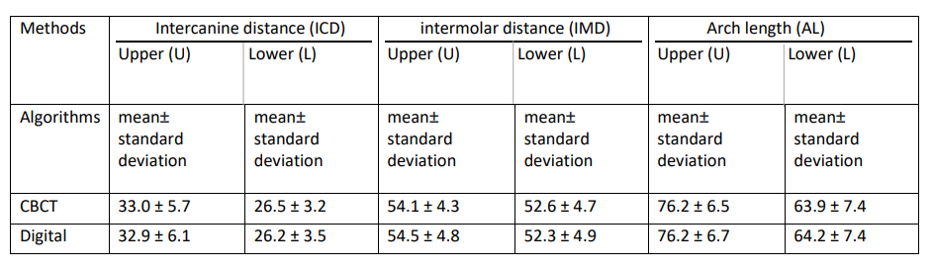 Gap analysis, Figure 2.1

as shown in the gap analysis the approach of the related works is either the average or standard deviation of parameters like ICD, IMD, and AL were computed. Although these calculations revealed slight disparities, they did not reach statistical significance (P < 0.05; paired Student's t-test)., what our proposed system hopes to achieve is the ability to use both images to compare them and evaluate the student and give him the grades he deserves.

## literature review

All measurements were meticulously recorded and organized in an Excel spreadsheet. A comprehensive statistical analysis was then carried out using SPSS v.15.0 software for Windows. To ensure the suitability of the data for analysis, the Kolmogorov-Smirnov test, a statistical algorithm assessing conformity to a normal distribution for each variable, was employed. The results indicated that all variables adhered to a normal distribution, with significance values ranging from 0.100 to 0.989. Additionally, the correlation between variables obtained from both methods was assessed using Pearson’s correlation coefficient, a well-established measure of the strength and direction of linear relationships between variables. This analysis played a crucial role in estimating the slope and ordinate at the origin, alongside their corresponding 95 percent confidence intervals. The correlation coefficient aided in evaluating the closeness of measurements between the two methods, offering insights into the level of agreement or disagreement. Furthermore, to quantify the disparities between the two methods, differences in the mean values of each item determined by each method were calculated and contrasted with the mean value of the item measured using the Digital Method. These differences were expressed as percentages, providing a straightforward interpretation of the extent of discrepancies between the measurement methods. To evaluate measurement consistency with CBCT, seven out of the 27 patients were selected, and all measurements were repeated three times by the same observer, resulting in a total of 90 measurements. The coefficient of variation was found to be 1.8 percent for tooth sizes and 1.1 percent for measurements encompassing intercanine, intermolar, and AL measurements combined (IC: 1.6 percent, IM: 1.1 percent, and LAI: 0.7 percent). These values were analyzed together due to their relatively minor differences. It's worth noting that the reproducibility of the Digital Method had been previously examined (Patel V, Heffernan M, et al. 2020; Chen C, Bautista J, et al. 2018), revealing coefficients of 2.1 percent for tooth sizes and 1.7 percent for intercanine, intermolar, and AL measurements, which were also jointly analyzed due to their similar variation. Importantly, no calculation for interexaminer error in CBCT measurements was mentioned.

**Chapter 3**

# Specification - (SRS)

## Introduction

## The purpose of the project Developed a desktop application to compare 3D intraoral scan analysis using the iTero Scanner and manual dental measurements recorded by dental students, understanding the urgent need to provide a comprehensive technology solution to the dental community. This application comes with the main mission of developing and providing an effective and easy-to-use way for researchers and students in the field of dentistry to measure and compare clinical data taken from different sources. The iTero Scanner can provide accurate 3D data faster and more accurately than can be achieved manually, while manual measurements are an essential tool for teaching dental students. The goal of this design is to develop a user-friendly and robust application that can enable users to make accurate and comprehensive comparisons between iTero Scanner data and manual measurements quickly and effectively. This application will provide a simple, user-friendly, fit-for-purpose interface as well as technical data analysis tools that enable users to make institutional and applied use of the data. In addition, it helps physicians and researchers improve the quality of their research and clinical practice, which benefits the quality of health care patients receive. This application is considered an important contribution to the development of the field of dentistry and to enhancing the integration between technology and tradition.

#### **Scope of this document**

## Our software system is designed to improve the detection of discrepancies in measurements taken and the assessment of students in dental school. The program aims to achieve this goal by providing an effective and accurate means of comparing three-dimensional measurements taken using the iTero Scanner device with traditional manual measurements recorded by dental students. The main beneficiaries of this system are students faculty members in the College of Dentistry.

## 

## 3.1.2Overview

The system overview is divided into three main phases aimed at improving the accuracy and reliability of dental measurements using a dedicated desktop application for intercomparison analysis. These stages include the first phase of the input data. It involves collecting images from a 3D scanner in perfect format with the correct dimensions and from dental students using traditional methods.  
second phase of data processing It includes analyzing data to discover differences and measuring them in millimeters. The goal is to improve the accuracy of the system and provide accurate data to users.  
third phase Excretion It includes standardizing the results achieved from the comparison process, then comparing and evaluating them, and notifying users of the differences and evaluations.

#### **Business Context**

The development of a desktop application for comparative analysis of dental measurements is located in a business context that combines education and healthcare. On the educational side, the application is used as a valuable tool to enhance the education of dental students and improve their skills in dental measurements. The application also enhances faculty evaluation. It is Clinically, it contributes to improving patient care by achieving higher accuracy in measurements, which contributes to treatment planning and device design. This project fits into the trend of digitalization in the dental sector and aims to meet the diverse needs and expectations of stakeholders in this field. It is also committed to compliance with legal and ethical requirements and emphasizes user orientation through user-friendly and effective design.

## 

## 

## Figure 3.1: A picture of the ideal measurement of the iTero oral scanner in the dental clinic.

## General Description

The primary objective of the system is to create a measurement comparison tool where the application allows users to compare measurements between manual measurements recorded by dental students and digital measurements taken using the iTero Scanner. The application shows the differences between them in a simple and clear way. Data Analysis The application can accurately analyze data and extract important information from it, allowing users to have a deeper understanding of the results and changes in measurements.

**3.2.1.1Faculty members at the College of Dentistry**

* They can use the app as a powerful educational tool to effectively guide students as well as support research efforts by ensuring the accuracy of data used in studies and evaluations.
* The system helps in creating reports for faculty members for the purpose of effective evaluation and follow-up.

**3.2.1.2Students of the College of Dentistry**

* Students can greatly enhance their practical skills by comparing their manual dental measurements to digital measurements, giving them a deeper understanding of 3D concepts.
* The system helps in generating reports for students for the purpose of effective assessment, tracking, and providing accurate analyses of students’ performance in the field of dentistry.

##### **3.2.1.3 Dental clinics**

* Ability to access and update data sets related to dental measurements.
* access to datasets for naming and recording purposes.
* Receive instant alerts on student assessment reports.
* Access important information about ideal tooth sizes and comparisons of student measurements before and after preparing for crown placement, enhancing your ability to make informed decisions and provide optimal patient care.

**3.2.1.4 Developer**

* As a developer, it is imperative that the system exhibit dynamic flexibility, allowing seamless integration with diverse systems of varying scales. Furthermore, the system should demonstrate adaptability by efficiently accommodating different datasets, ensuring its versatility in handling various data sources.

#### **Similar System Information**

#### **User Characteristics**

There are two distinct groups of users in the system. First, there are the developers who will be using the framework in the proposed system they are working on. Second, there are the end users who will be running the system and have the ability to apply it to a variety of scales in different ways by loading the appropriate dataset and features. The system generates a final report for these users, who may be either academic students or the doctor responsible for evaluating the students. The proposed system will require users with specific characteristics, as follows:

* Adequate knowledge of the English language.
* Low and medium computer knowledge levels.

#### **User Problem Statement**

* Inaccurate assessment of students: If the measurements students take are inaccurate, the final assessment of their performance may be unfair and may not reflect their true abilities.
* Errors in diagnosis and treatment: If these inaccurate measurements are used to diagnose patients’ conditions or in dental treatments, this may lead to medical errors and negative repercussions on patients’ health.
* Wasting time and effort: Correcting incorrect measurements and rework may require additional tasks of time and effort, wasting significant resources.
* Loss of confidence in the educational process: If there is no reliable way to evaluate student performance, teachers and students may lose confidence in the quality of education and assessment.

#### **User Objectives**

As an academic doctor:

* Conducting a set of measurement tests to verify the validity and accuracy of the program in evaluating students’ performance.
* Obtain a monthly report that includes students’ grades and an accurate assessment of their performance.
* Identify errors and differences in student performance, including measurements, before and after preparation and training.

As a developer:

* The need to develop a reusable tool that can be used to build similar systems in the future.
* The need to develop a flexible tool that allows different datasets to be loaded dynamically and is suitable for different situations in the program.

## Functional Requirements